**CHANDIGARH UNIVERSITY**

**UNIVERSITY INSTITUTE OF ENGINEERING**

**DEPARTMENT OF COMPUTER SCIENCE AND ENGINEERING**



|  |  |
| --- | --- |
| **Submitted by:**  Yash Gupta 20BCS5009 | **Submitted To:**  Ajay Kumar (E13141) |
| **Subject Name:** | Machine Learning Lab |
| **Subject Code:** | 20CSP-317 |
| **Branch:** | CSE |
| **Semester:** | 5th |

LAB INDEX

|  |  |  |  |  |  |  |  |
| --- | --- | --- | --- | --- | --- | --- | --- |
| **Sr.No** | **Program** | **Date** | **Evaluation** | | | | **Sign** |
| **LW(12)** | **VV(8)** | **FW(10)** | **Total (30)** |
|  |  |  |  |  |  |  |  |
|  |  |  |  |  |  |  |  |
|  |  |  |  |  |  |  |  |
|  |  |  |  |  |  |  |  |
|  |  |  |  |  |  |  |  |
|  |  |  |  |  |  |  |  |
|  |  |  |  |  |  |  |  |
|  |  |  |  |  |  |  |  |

**Experiment 2.2**

**1. Aim/Overview of the practical:**

**Naïve Bayes theorem**

**2. Source Code:**

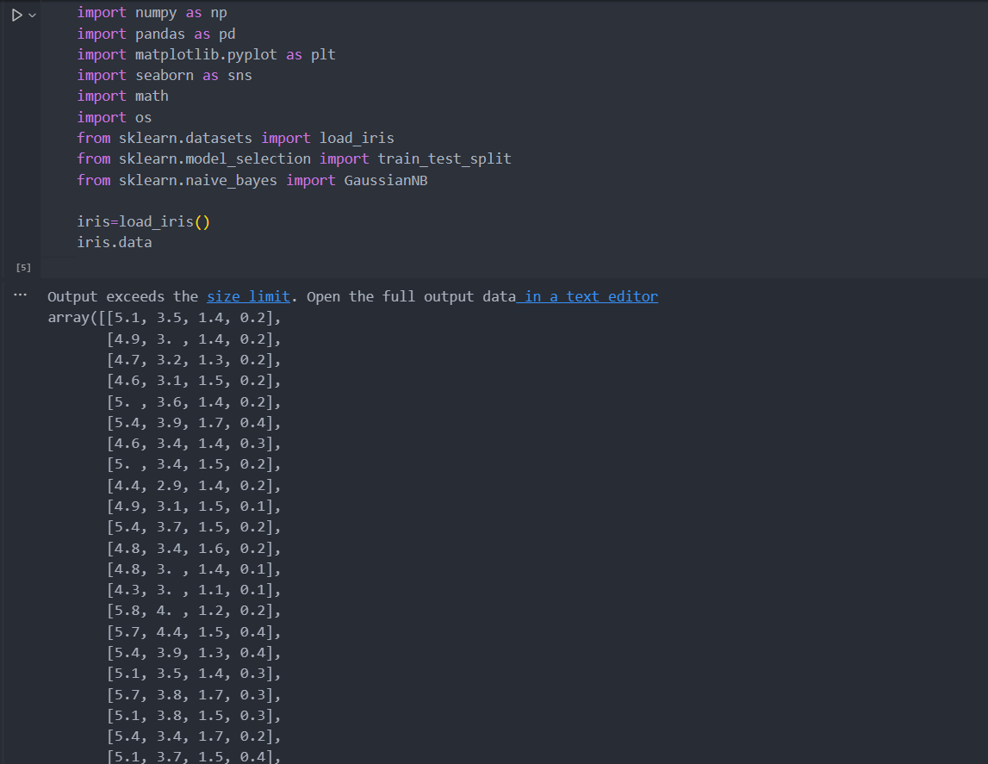

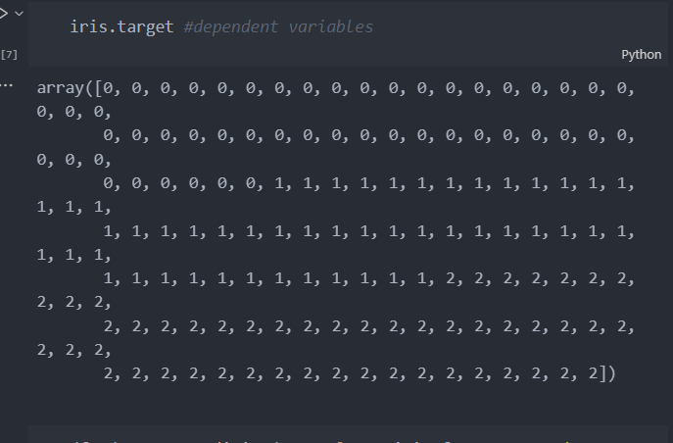

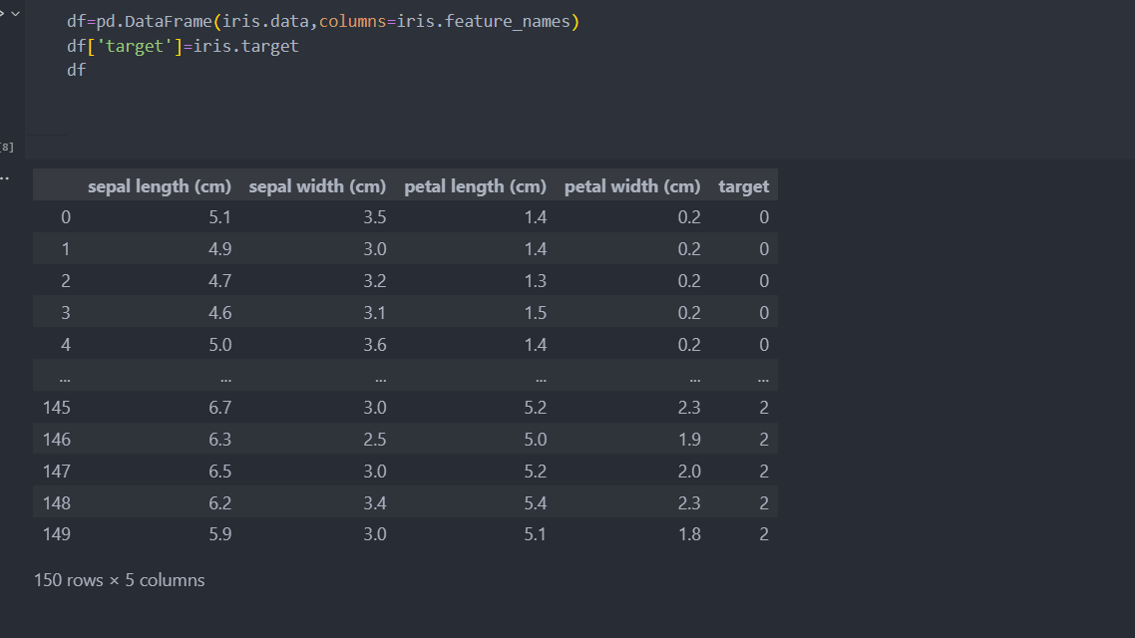

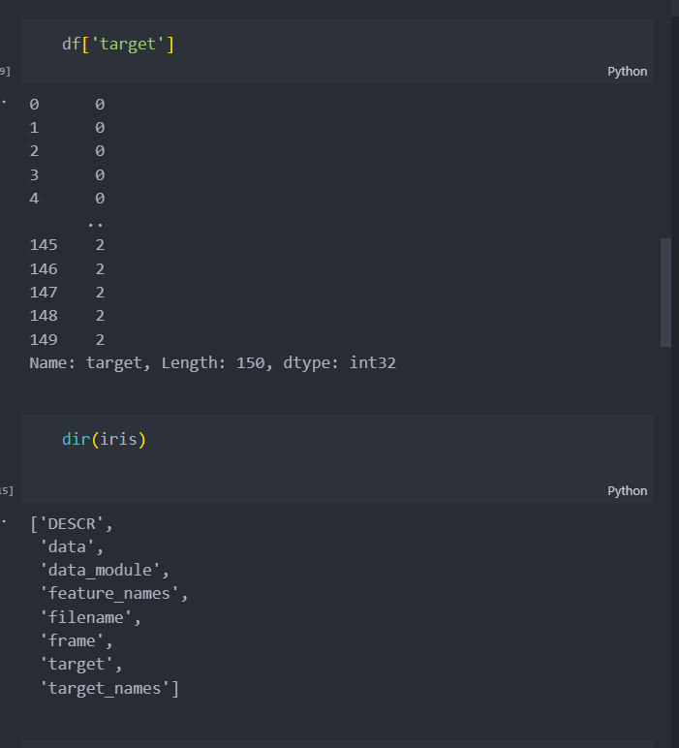

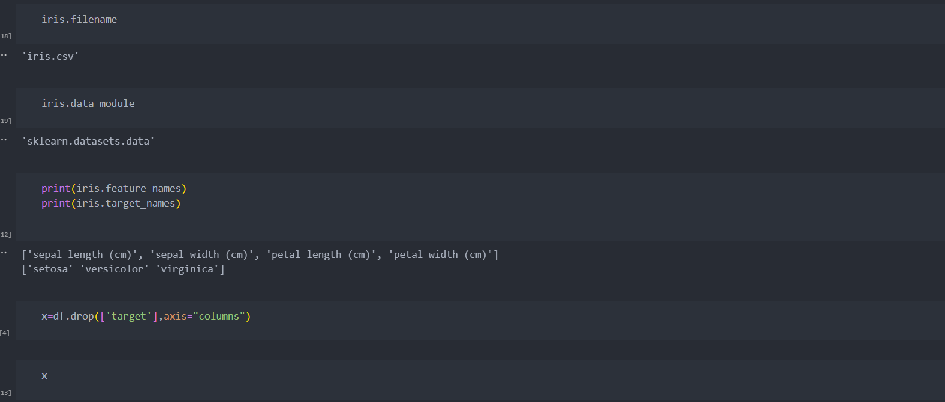

**3. Result/Output**

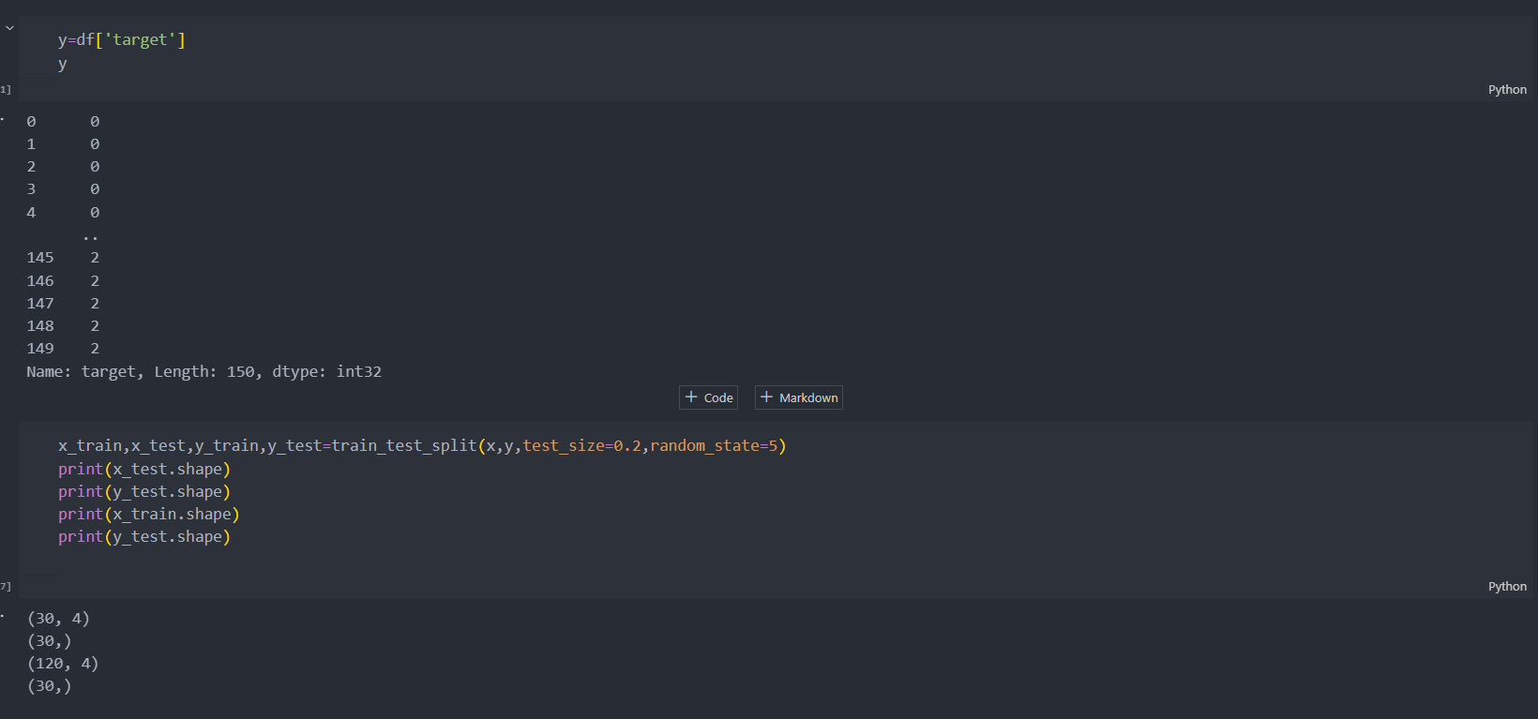

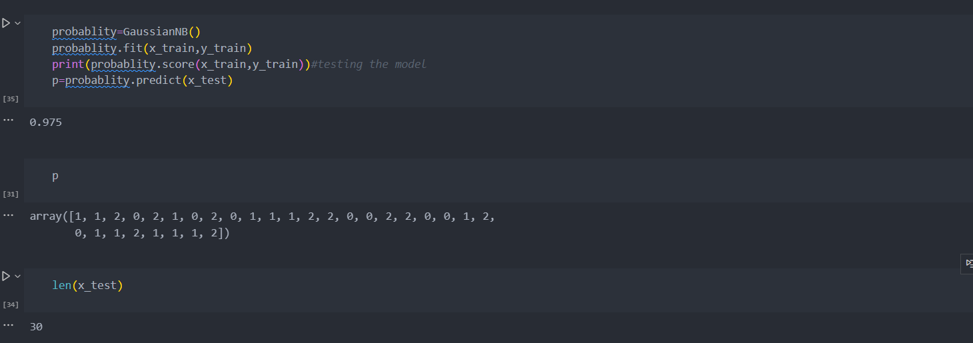

**Evaluation Grid :**

|  |  |  |  |
| --- | --- | --- | --- |
| **Sr. No.** | **Parameters** | **Marks Obtained** | **Maximum Marks** |
| **1.** | **Student Performance  (Conduct of experiment) objectives/Outcomes.** |  | **12** |
| **2.** | **Viva Voce** |  | **10** |
| **3.** | **Submission of Work Sheet (Record)** |  | **8** |
|  | **Total** |  | **30** |